Self-Massage the Runner's Way

Tend to your aches yourself with this guide
By Caitlin Chock As featured in the January 2012 issue of Running Times Magazine
Who doesn't love a massage? And who doesn't think, "I wish I could get massages more often"? Enter self-massage.
If you do it right, self-massage can serve as a form of maintenance between massages given by a trained therapist. Self-massage can "take care of the tightness that comes up with day-to-day training," says Julia Kirtland, the 1997 national marathon champion who's now a massage therapist in Portland, Maine. It can "break up adhesions before they cause problems."
TOUCHING TIPS
Before you dive into daily self-massage, here are some general guidelines.
MASSAGE MODERATION: "More is not always better," says Al Kupczak, a massage therapist who works with elites in Boulder, Colo. Don't zone out while watching TV and wind up working one area for more than 10 or 15 minutes. Instead, be diligent over your entire body and address all the muscle groups. In addition, says Kirtland, "I would say a few minutes a day is better than once a week for half an hour."
DON'T TRY TO BULLY AN ACHE AWAY: A common mistake is to over-massage an already inflamed area. Overdoing it on compromised soft tissue can lead to more inflammation and a longer recovery period. Again, focus on a specific spot for no more than 10 to 15 minutes, then move on.
EASE UP: Our body's muscles and connective tissues are complex and sensitive; they react to stimuli such as pressure, heat, and speed differently. With pressure, it's a matter of easing into it and not going too hard. "It sounds counterintuitive," says Kupczak, "but pressure does not equal depth." Going too hard, too fast causes the muscle to seize up when what you want it to do is release. Think of warming up into the massage, like you would a workout, and then avoid going too hard.
THE HANDS HAVE IT: Tools can't sense your muscles relaxing; only your hands can. When using any implement to self-massage, stop occasionally to check in with your hands and feel how your muscles are reacting.
KNOW YOUR LIMITS: They're called professional massage therapists for a reason; they spend years learning and applying these techniques. Self-massage is excellent upkeep, but have the wisdom to recognize when a problem calls for the pros. "It is possible that the pain or injury isn't one that would respond well to massage, so it would be more beneficial to have an experienced individual helping you when things are really hurting," says Kendall Schoolmeester, a former Colorado University runner who's provided massage for the Nike Oregon Project members.
TOOLS OF THE SELF-MASSAGE TRADE
FOAM ROLLER: It's best for covering larger areas such as the quads, hamstrings and IT band. Lie with the intended target on the roller and then slowly roll the full length of the muscle group, starting where the muscle begins and stopping where it inserts at the end. Ease into the massage and gradually apply more pressure via increased body weight.
SMALL SCREWDRIVER HANDLE: Think of this as the miniature version of the foam roller; it lets you get to smaller areas better and is great for the tricky-to-reach spots around your hips and other bonier regions. Firmly grip just below the base of the handle on the metal portion and massage with the long end of the handle. Gradually apply pressure using long, broad strokes. You can also use the blunt end on a specific point; use direct pressure for 10 seconds at each acute point to help loosen the muscle. Think of this like a massage therapist would use her thumb or finger to push into the tissue and move from point to point across the muscle.
THE STICK: Gripping both ends firmly with your hand, use this tool to rub up and down across the length of your muscles (mostly quads, hamstrings, calf muscles and IT band). This works in a similar fashion to the foam roller, but instead of using your body weight you're applying the pressure with your arms. A rolling pin can be a good-enough substitute.
GOLF BALL: Along with tennis balls, these are excellent for rolling along the bottom of your feet and loosening up the plantar fascia. Roll across the entire length of the muscle or tendon in a long, controlled motion. For areas around the hips and glutes, putting your body weight on top of the tennis ball and kneading it in circles is great at breaking up tension in bony, hard-to-reach areas.
FOUR KEY SELF-MASSAGES
1) FOAM ROLLER FOR THE IT BAND: Lie with one side of your leg on top of the roller; start at the top of the IT band where the muscle inserts at the hip. Distribute your body weight in variance to the degree of pressure you should be applying, using your arms for support if necessary. Roll down the length of the IT band until you get to the top of the knee and back up. Use a slow, long rolling motion.
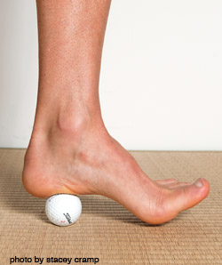
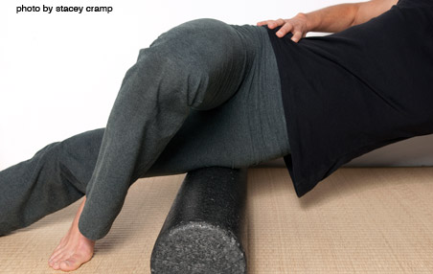
2) GOLF BALL FOR THE PLANTAR FASCIA:
Rest your foot on top of the ball and take the majority of your body weight off of that foot by sitting or using something for balance. Gradually apply more pressure to the foot on the ball as you roll your sole across it in long strokes from the base of the heel and up to your forefoot. Roll up and down; you can do lengthwise as well.
3 SMALL SCREWDRIVER HANDLE FOR THE GLUTES: Use the blunt end of the screwdriver to apply direct pressure into the gluteus maximus (instead of doing a rolling motion). Along the glute and hip regions lies a tightly condensed network of pressure points, especially along the top ridge of your hips, known as the iliac crest. Press and hold the handle in one spot, keep it there for 10 seconds, and then move up or down to the next spot. You'll feel the pressure points as you hit them, like hitting a sore spot in your muscle. Ease into it and don't put yourself in excruciating pain.
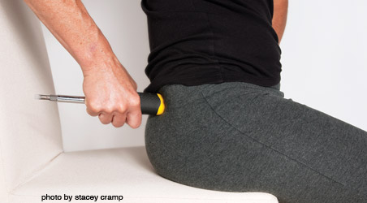
4) THE STICK FOR THE CALVES: Sitting, hold the stick with both hands and use it to rub along the full length of your calf muscle. Start at the base of the knee and go down to the top of the Achilles in a controlled motion, and then back up.
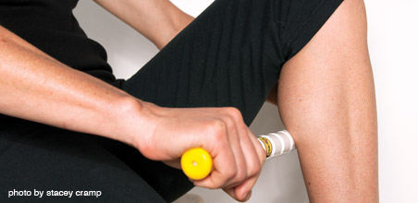
How Hard is Too Hard?
The key with self-massage is listening to the signals your body is sending you and keeping any discomfort as that--slight discomfort--rather than excruciating pain. What makes self-massage tricky is that, in addition to trying to read what your body's telling you from the outside, you're also getting internal messages. To counteract potentially overriding sensations of what your muscles are relaying to your brain, fall back on what your hands are able to feel. See if your muscles are relaxing and loosening before proceeding. There's a level of applied science here that only a trained massage therapist can master, but as with the rest of your training, by listening to and learning from your body's signals, you can progress.

