RUN FOR STARFISH IN THE 2017 COMRADES MARATHON AND ADD A SMILE TO A CHILD’S LIFE!
Young children are usually the first people to suffer when poverty strikes. Poor nutrition, disease, abuse and lack of proper education can cause a child’s life to be ruined before it even starts. Millions of South African children are in this situation. Starfish Greathearts Foundation helps children where they need it most – in their homes and communities. Through our network of community-based NGO’s across South Africa, we give children the essentials to get the chance to lead a normal, productive and healthy life.
We have literally hundreds of success stories to share. Here is one:
THE PROBLEM – malnutrition and illness
THE STARFISH PARTNER - The SETHANI CENTRE in the KwaNgcolosi community alongside the Inanda Dam near Durban.
THE SOLUTION
Mbongeni, a 14-year-old boy and his 9-year-old sister, Samkelisiwe, lived with their mother, who suffered from dementia. She was unable to care for them and the situation was spiralling out of control. A community health worker reported the case to Sethani, which took over the nutritional support for the family also and made arrangements for the mother to receive medical attention.
Sethani will provide ongoing support to the children via a monthly food parcel and school uniforms for the year. Because there is no outside family care for the children, Mbongeni is receiving counselling as he is now the head of the household.
Sethani also facilitated a very emotional visit between the children and their mother at the facility where she is receiving care.
Where there was desperation, there is now healing and hope.
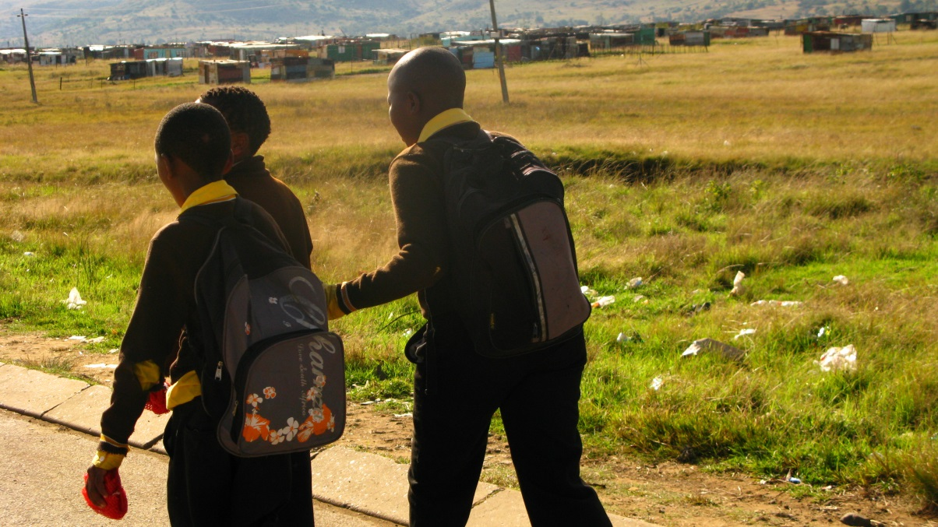
YOUR ROLE
What can you do to help children like Mbongeni and Samkelisiwe, who cannot help themselves?
If you are a Comrades runner, sign up for Race4Charity by visiting Comrades.com. Raise R5 000 by 2 May and qualify to run in CC batch.
If you are not a runner, but still wish to help, go to Comrades.com, find the Race4Charity tab, follow the links and donate on-line to someone running for Starfish.
Every rand helps children like Mbongeni and Samkelisiwe.

