RUN FOR STARFISH IN THE 2017 COMRADES MARATHON!
Young children are usually the first people to suffer when poverty strikes. Poor nutrition, disease, abuse and lack of proper education can cause a child’s life to be ruined before it even starts. Millions of South African children are in this situation. Starfish Greathearts Foundation helps children where they need it most – in their homes and communities. Through our network of community-based NGO’s across South Africa, we give children the essentials to get the chance to lead a normal, productive and healthy life.
We have literally hundreds of success stories to share. Here is one:
THE PROBLEM – Education
THE STARFISH PARTNER - THY KINGDOM CARE CENTRE near Vanderbijlpark in the Vaal Triangle.
THE SOLUTION
Thapelo, in grade 8, lives with his younger brother, Thabang, who is in grade 6, in a one-roomed shack in an informal settlement. Their mother is unable to work due to poor health. The family survives on only the meager child support grants they receive, which is less than R1 000 per month. Through Thy Kingdom’s intervention, the boys’ education has been the primary focus and a dedicated care-worker assists them with their schoolwork. They now also have the school uniforms essential to receive an education. The pair also gets a proper meal every day after school.
On a weekly basis, the assigned care-worker conducts general counselling to ensure that the family receives the essential support they need in a very difficult environment.
Where there was desperation, there is now education, support and hope.
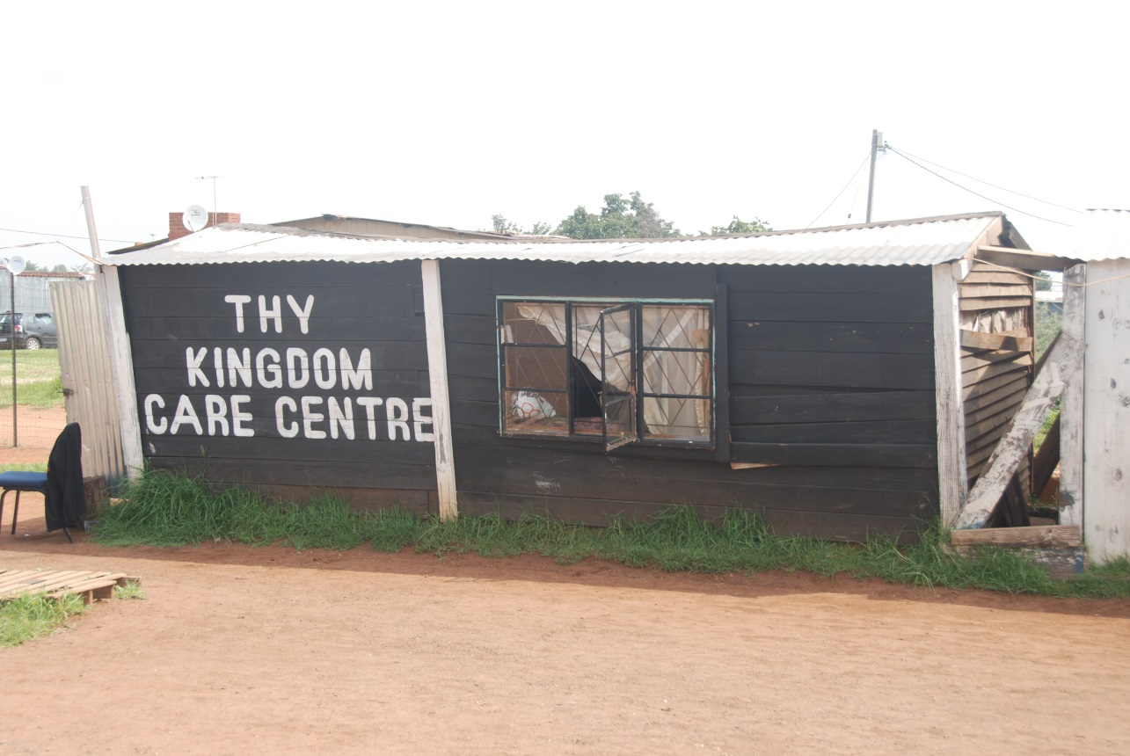

YOUR ROLE
What can you do to help children like Thapelo and Thabang?
If you are a Comrades runner, sign up for Race4Charity by visiting Comrades.com. Raise R5 000 by 2 May and qualify to run in CC batch.
If you are not a runner, but still wish to help, go to Comrades.com, find the Race4Charity tab, follow the links and donate on-line to someone running for Starfish.
Every rand helps children like Thapelo and Thabang.

