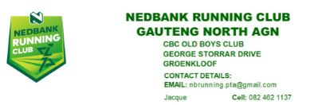
20 January 2022
ANNUAL GENERAL MEETING NOTICE
AGENDA OF THE NEDBANK RUNNING CLUB GAUTENG NORTH AGN
DATE: 20 January 2022
TIME: 19H00
VENUE: CBC Old Boys Club, George Storrar Drive, Groenkloof
- Opening and Welcome
- Establish if there is a quorum
- Read and confirm the notice of the meeting
- Minutes of previous meeting and approval
- Submitting, discussion and approval of annual report from chairman
- Submitting, discussion and approval of financial statements.
- Election of new management
- Closing
All COVID 19 protocols will be adhered to: Temperature checks when registering upon arrival, wear your mask, sanitize and social distancing will apply.
Jacqueline Rencontre
Chairman

