Have you been diagnosed with
Achilles Tendinopathy???
Take part in our study and receive treatment!

What is Achilles Tendinopathy?
Pain and swelling of the Achilles tendon at the back of your heel.

Signs and symptoms:
- Pain may occur with ankle movement with daily activities or sport (as shown
in the region of the dot on the picture)
- Pain when your ankle is at rest
- Pain with pressure on the tendon
- Pain when climbing stairs or doing calf raises.

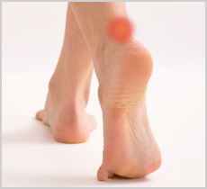

For more details to participate in the ethically approved research study regarding TREATMENT, contact:
(c) 082 096 3204 or
083 361 9296 of under supervision of Mrs. A Marais

