The Nedbank Modderfontein sub-club is having FUN while they RUN!
The Nedbank RC in CGA do have a sub club in Modderfontein and it looks like a lot of fun is happening here!
The clubs time trial route is inside the Modderfontein reserve and a very nice route to add to your training regime.
It will be worth visiting this club and join in their club runs, time trials and festivity events.
The Christmas club-run
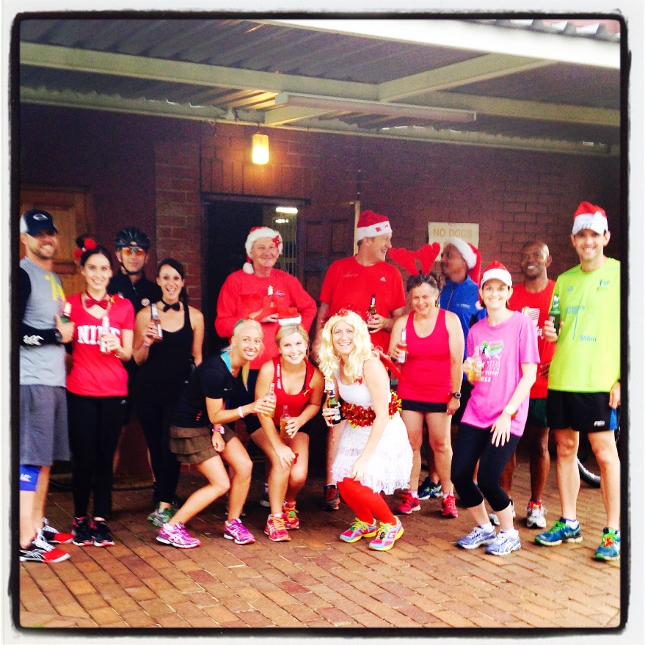
The 4x 2 Relay The Bobbies Relay
